

‘Together we dream, believe and achieve’

POLICY FOR ENGLISH

Document name | English
Authors | A Wright
Date approved | October 2025
Current document | Version 3
Review date | September 2027

English Policy

INTENT
Language and literacy are of personal, social and economic importance. Our ability to use language lies at the centre of the development and expression of our emotions, our thinking, our learning and our sense of personal identity. Language is itself a key aspect of our culture; through language, children and young people can gain access to the literary heritage of humanity and develop their appreciation of the richness and breadth of our literary heritage. Learning to read in the first years of primary school is critical for retention and success in future years. Literacy is the cornerstone of development; it leads to better health, better employment opportunities, safer and more stable societies. Indeed, Literacy has been defined as 'the set of skills which allows an individual to engage fully in society and in learning, through the different forms of language, and the range of texts, which society values and finds useful.'
When our children leave Redhill, we strive for them to be avid readers - children who read fluently and widely and are able to express preferences and opinions about the texts that they read. We want them to regularly read for pleasure, having had access to a wide range of text types, genres and authors in order for them to make informed opinions about their favourites.
Our aim is to produce children who write with confidence and accuracy for a variety of purposes and audiences whilst developing their own individual flair. We want our children to be able to write with grammatical accuracy and be able to apply spelling patterns correctly using a neat handwriting style. We aim to expose our children to a wide range of vocabulary so that they able to decipher new words and then use them when speaking both informally and formally.
We expect our children to apply all of these English skills to all areas of the curriculum and to utilise their language and literacy skills and knowledge in all subjects and in their everyday lives.
Our approach is underpinned by high expectations; all children are expected to make accelerated progress from their starting points and we expect that every child, where possible, passes the phonics check in Year 1. In Year 6 we aim for a majority of children to achieve the ‘greater depth’ standard. We have achieved these high standards consistently and Redhill is often placed in the top 10% of schools nationally for reading results. These high expectations also apply to our teachers who we can rely on to teach and model the skills needed to succeed in English, providing examples of good practice and having high expectations.
At Redhill it is our intention that children develop the skills and knowledge that will enable them to communicate creatively through spoken and written language and develop their love of literature through reading for enjoyment. By the end of Key Stage 2, we aim for our pupils to:
- read easily, fluently and with good understanding
- develop a love of reading and the habit of reading widely and often, for both pleasure and information
- acquire a wide vocabulary, an understanding of grammar and knowledge of linguistic conventions for reading, writing and spoken language
- appreciate our rich and varied literary heritage
- write clearly, accurately and coherently, adapting their language and style in and for a range of contexts, purposes and audiences
- use discussion in order to learn; they should be able to elaborate and explain clearly their understanding and ideas
- be competent in the arts of speaking and listening, making formal presentations, demonstrating to others and participating in debate.
Our approach to teaching Literacy is grounded in evidenced based approaches. Reading and writing are both taught with regard to the ‘gradual release of responsibility’ model and teachers and support staff receive regular training in the most effective strategies for teaching literacy and effective interventions.

IMPLEMENTATION: CURRICULUM ORGANISATION PLANNING
At Redhill we plan English at three levels:

- Long Term: The National Curriculum (2014) and Foundation Stage Curriculum defines the content that will be taught to each year group. The Redhill Learning Journey Framework adds further detail and demonstrates progression in reading, writing, spelling and grammar. In addition, Redhill uses Phonics Bug as a scheme for phonic progression. Redhill has identified writing genres for each year group as well as texts to be covered. The texts have been chosen with the aim to enrich children’s cultural capital, to introduce them to the diversity of society as well as the best which has been said or thought.

- Medium Term: Teachers produce a plan, which provides the content for each half term based upon the The Redhill Learning Journey Framework or The EYFS Framework. A meaningful storybook context is provided for the Literacy in every year group, ensuring that thorough coverage is combined with a creative and stimulating curriculum. Medium term planning is designed to be progressive and allow opportunity for reflection and low skills testing in a way that helps children take control of their learning and develop meta-cognition strategies. The storybook approach means that teachers are clear about the texts which children know ‘inside out’.

- Short Term/Unit planning: An agreed proforma is available for teachers to use if required which outlines the objectives, differentiation, identifies PP children those with an IEP and other vulnerable groups.

IMPLEMENTATION: TEACHING APPROACHES

English at Redhill is taught through an immersive storybook curriculum with a cross curricular focus which provides opportunities for developing a high quality vocabulary and confident writers. English is taught daily, either explicitly or as an integral part of other curriculum areas as part of our Mastery approach to learning. Our approach to each strand of English is detailed below, although there is much overlap and skills in one area impact on the next.

Reading is taught explicitly through standalone lessons, through a mixture of whole class and guided reading. Reading for pleasure is given a high priority and throughout the year teachers employ a variety of
strategies to motivate children’s reading. In addition, children are encouraged to read to an adult regularly, with older children completing reading homework linked to the VIPERS comprehension strategies. There is a progressive reading scheme which allows choice and range within each level. Our pedagogical approach to reading is outlined in Appendix 1 and in our Reading at Redhill booklet (Appendix 3) .

Reading for pleasure is a priority for Redhill as we want to encourage our children to be lifelong readers with a joy and passion for reading. Therefore, every class reads a class novel several times a week, we regularly update and maintain our library to make it a vibrant, exciting place for children to choose books in an intuitive way, we encourage and celebrate independent reading where possible and we look for opportunities throughout the year to raise the profile of reading across school.

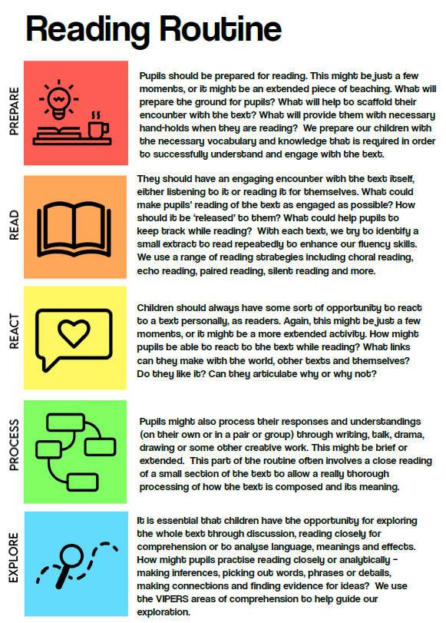

Phonics: Early reading is taught using synthetic phonics. They are taught to use their phonic skills and knowledge as their first approach to reading, but are also taught ‘tricky words’ which do not completely follow the phonic rules. Phonics teaching is based on the Phonics Bug scheme. Children have are given books which precisely match their phonic phase and need. All children in Reception and Key stage 1 take part in a daily twenty minute, high quality phonics sessions which follow the recommended sequence of teaching – revise, learn, practice, apply. Our phonics approach is outlined in detail in our Phonics at Redhill booklet (Appendix 4)

Spelling is taught daily, through teacher led sessions as well as independent practise using a variety of strategies including online resources. The Redhill Learning Journey Framework sets out spelling lists for each year group based on the Spelling Shed scheme, in addition to the National curriculum common exception lists. In writing, spelling is given a high priority. Children are given ‘no excuse’ words and all teachers follow up on mis-spelled words in extended writing pieces in age-appropriate ways. A focus on vocabulary also provides support for spelling.

Writing is taught through a variety of approaches such as discrete lessons, drama and through other subjects. There is an expectation of one piece of extended writing every two weeks. Units of writing follow a teaching sequence called the Redhill Writing Routine:
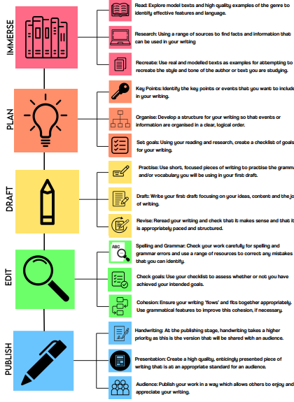
Throughout the school year, children are given the opportunity to develop all five components of the writing routine. Writing is a key skill across all areas of the curriculum and given high priority in other subject areas. Vocabulary is another key focus across all subjects and the Redhill Learning Journey Framework sets out tier 2 and level 3 vocabulary (Beck et al, 2002) which should be explicitly taught to children. Both reading and writing are underpinned by a focus on language acquisition and oracy.
Our writing approach is outlined in more detail in our Writing at Redhill Booklet (Appendix 2) and in our Redhill Writing Routine (available on the English curriculum page of our website).
Grammar and punctuation: these objectives are integrated through the writing curriculum, supported by lessons where these skills are explicitly and discretely taught to ensure they are embedded. The progression of objectives is made clear through the Redhill Learning Journey Framework.
Handwriting and presentation: At Redhill, children are taught to write legibly, fluently and at a reasonable speed. In line with the National Curriculum guidance, we teach cursive writing from year 2 upwards.
Oracy and Spoken Language: The National Curriculum for English reflects the importance of spoken language in pupils’ development across the whole curriculum – cognitively, socially and linguistically. Spoken language underpins the development of reading and writing. The quality and variety of language that pupils hear and speak are vital for developing their vocabulary and grammar and their understanding for reading and writing. Teachers should therefore ensure the continual development of pupils’ confidence and competence in spoken language and listening skills.
Pupils should develop a capacity to explain their understanding of books and other reading, and to prepare their ideas before they write. They must be assisted in making their thinking clear to themselves as well as to others and teachers should ensure that pupils build secure foundations by using discussion to probe and remedy their misconceptions. Pupils should also be taught to understand and use the conventions for discussion and debate. All pupils should be enabled to participate in and gain knowledge, skills and understanding associated with the artistic practice of drama. Pupils should be able to adopt, create and sustain a range of roles, responding appropriately to others in role. They should have opportunities to improvise, devise and script drama for one another and a range of audiences, as well as to rehearse, refine, share and respond thoughtfully to drama and theatre performances. Statutory requirements which underpin all aspects of spoken language across the six years of primary education form part of the national curriculum.
EQUAL OPPORTUNITIES
Positive attitudes towards English are encouraged, so that all children, regardless of race, gender, ability or special needs, including those for whom English is a second language, develop an enjoyment and confidence with reading and writing. This policy is in line with the school’s ‘Racial Equality’ policy.
The aim is to ensure that everyone makes progress and gains positively from lessons and to plan inclusive lessons. Lessons involving many varied elements will benefit all children including those for whom English is an additional language (EAL).
Differentiated questions are used in lessons to help children and planned support from Teaching Assistants and other adults.
INCLUSION
In planning work the teachers will aim:
• to provide breadth and balance of language activities for all children
• to provide a differentiated English curriculum to meet the needs of all the children through the continuity of experiences
• to set suitable learning challenges for individuals or small groups of children
• to respond to pupils diverse learning needs
• to liaise with the SENCO to ensure that provision is made for all children with SEN.
• to relate activities for SEN children to their individual targets and personal plans.
• to overcome potential barriers to learning and assessment for individuals and groups of pupils.
• to identify vulnerable groups who are not making expected progress, and provide appropriate support.
Pupils identified as needing extra support in English will be given the appropriate help in the classroom. Providing for pupils with special educational needs should take account of each pupil’s particular learning and assessment requirements and incorporate specific approaches which will allow individuals to succeed, such as using texts at an appropriate level of difficulty and planning for additional support.

FEEDBACK AND ASSESSMENT FEEDBACK
Feedback in English is important in several ways. In writing, it can help children to improve existing work. In all areas, it can scaffold children and help narrow the gap between what they can do independently and what they need support to achieve. It builds the ability to self-assess and helps children understand how to be responsible for their own learning. At Redhill, feedback for English is given in a variety of ways:
  - Whole class marking from Year 2 onwards, using a school-wide format, shared in ‘feedback, move on’ sessions where children practise skills identified through marking as well as make improvements in their own writing
  - In-lesson feedback and adaptation of learning to meet children’s needs
  - Self-assessment against a given success criteria generated by the teacher or the children ( particularly in Big Writing)
  - Evidence of self-editing and improving
  - Peer assessment
  - Verbal feedback
  - Writing conferences

ASSESSMENT
  - Assessments are most often formative in nature and used to adapt the learning to support progression. Such assessments are informal in nature and take place throughout lessons. Steps for learning are shared with children, for example through writing target bookmarks and ‘no excuse’ spelling lists. The use of online resources such as Spelling Shed and Reading Eggs allows children to work on more personalised objectives.
  - Assessment in phonics is robust and children are assessed at least every half term, but usually more regularly. A home-school phonics folder allows a bespoke phonics curriculum for each child.
  - Assessment in writing is on-going and teachers use year group objective ticklists
  - Progress in English is reported three times a year to parents – at two parents’ evenings and in the end of year report. In addition, a half-termly report informs parents of attainment and effort in reading and writing.
  - Children are assessed on entering the school and are formally assessed at the end of the Foundation Stage, Key Stage 1 and 2.
  - There is a Phonics Screening Check for Year 1. Optional tests are used in years 3, 4 and 5 as a form of summative assessment.
  - Teachers use assessment for learning to ensure planning is based on prior attainment and that pupils know what they need to do to achieve the next steps.
  - Analysis of assessment data is used to set numerical targets and a whole school English curricular target(s).
  - Teachers keeps individual records. These include a reading record and any other information that enables the teacher to deliver an effective, relevant curriculum which builds on prior attainment and meets the needs of pupil. Termly pupil progress meetings help ensure rapid and sustained progress for all children.
  - Children are involved in their own assessment through the setting of success criteria. Children regularly assess their own work and that of their peers.

MONITORING

English is monitored by teachers, the English subject leader, the Headteacher and English Governor. Having identified priorities, the English subject leader constructs an action plan that forms part of the School Development Plan. This forms the basis for any monitoring activities and will clearly identify when, who and what is to be monitored and how this will take place e.g. classroom observation, planning scrutiny, work sampling. The English Governor and the English leader meet once a term to discuss priorities and areas for development.

ROLES AND RESPONSIBILITIES

Head Teacher and Governing Body
• Support the use of appropriate teaching strategies by allocating resources effectively.
• Ensure that the school buildings and premises are best used to support successful teaching and learning.
• Monitor teaching strategies in the light of health and safety regulations.
• Monitor how effective teaching and learning strategies are in terms of raising pupil Attainment.
• Ensure that staff development and performance management policies promote good quality teaching.

Subject Leader
• To have an impact on raising standards of attainment for English across the whole school.
• Adapt and use the Programme of Study for English across the whole school that meets the needs of our children.
• To monitor the whole school and individual needs to be able to assess individual professional development opportunities and needs.
• To maintain the availability of high-quality resources.
• To maintain an overview of current trends and developments within the subject.
• To ensure, together with the Head Teacher and Assessment Lead, a rigorous and effective programme of moderation of assessments.
• To ensure a regular and effective programme of analysis of children’s work sample monitoring is in place.
• To ensure a regular and effective programme of analysis of short-term planning is in place.
• To effectively manage any funding designated to English.

Class Teachers
• Ensure the effective implementation of the New National Curriculum for English.
• Adapt and use the Programme of study for English across the whole school that meets the needs of our children.
• Make effective use of Assessment for learning within English.
• To ensure work is planned to enable all children to reach their full potential.

Teaching Assistants
• To support the class teacher in the effective implementation of English.

Parents/Carers
We believe that parents have a fundamental role to play in helping children to learn. We do all we can to inform parents about what and how their children are learning by:
• holding parents’ evenings to discuss children’s progress
• sending an annual report to parents in which we explain the progress made by each child and indicate how the child can develop their learning
• explaining to parents how they can support their children with homework and English learning.

MONITORING AND EVALUATION
This policy will be reviewed annually by the English coordinator, in consultation with the staff, and as and when elements of English are identified or prioritised within the School Development Plan.
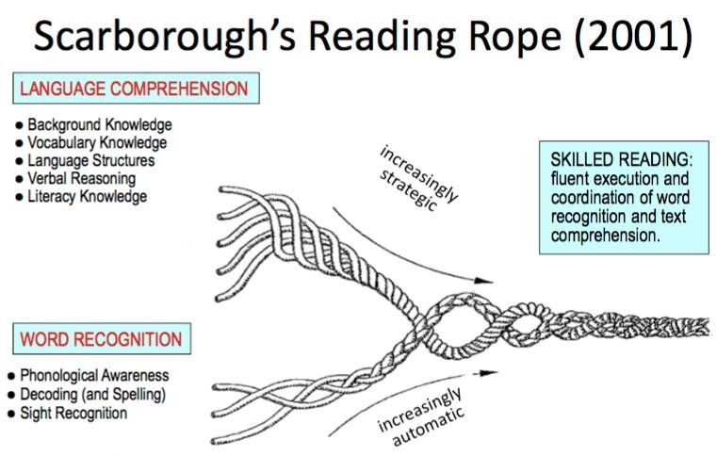
APPENDIX 1 – READING STRATEGIES POCKET PEDAGOGY: Reading in KS2
In Key Stage Two, teaching of reading fits the ‘gradual release of responsibility’ model:
- Whole class reading is used to explicitly teach reading comprehension
- Group reading is used to practice reading comprehension and develop fluency
- One to one reading is used to develop fluency and target specific issues children have with reading

Whole class reading | - Teaching the application of the ‘super seven reading strategies’ –predict, question, make links, look for clues, summarise, be a word detective, visualise  - Modelling inference-making by thinking aloud and scaffolding the thinking of children  - Structured questioning – VIPERS used to ensure coverage of different types of comprehension questions  - Pupils articulating answers before they start writing  - Vocabulary discussion and development  - Texts carefully chosen to challenge, to incorporate inclusive diversity and to introduce children to the best that has been ‘thought or said’
Group reading | - Developing fluency to reduce the cognitive load and allow more emphasis on comprehension through:  - guided oral reading instruction—teachers model fluent reading of a text, then pupils read the same text aloud with appropriate feedback  - repeated reading—pupils reread a short and meaningful passage a set number of times or until they reach a suitable level of fluency  - Discussion of appropriate reading strategies and encouraging children to check their own comprehension and utilise the strategies.
One to One reading | Focus on specific areas of need using the Scarborough Reading Rope to identify gaps. 1:1 reading could:  - Develop fluency  - Work on gaps in phonological awareness  - Apply reading strategies with more independence

Interventions  Where children require more support for their reading, areas of need are assessed using the reading rope and fluency. Interventions include:  - 1:1 reading with an emphasis on modelling and practising fluency  - Explicit teaching and practise of phonics – KS1 phonics or less common sound- grapheme correspondences.  - Supporting comprehension strategies |  |  | Reading for pleasure  - A good range of books in each classroom and in the school library  - Regular opportunities for children to discuss their own reading, to recommend books or authors; adults in school also talk about their own reading habits  - Whole class novels in every junior class with 15 minutes reading to the class each day  - Whole school initiatives such as ‘Redhill  Reviewers’, or book/poetry day initiatives
Minimum | Whole class |  |  | Individual | class novel
Year 3 and 4 | Daily |  |  | Once every three weeks | 1 hour per week
Year 5 and 6 | Daily |  |  | Once every three weeks | 1 hour per week

POCKET PEDAGOGY: Reading in KS1
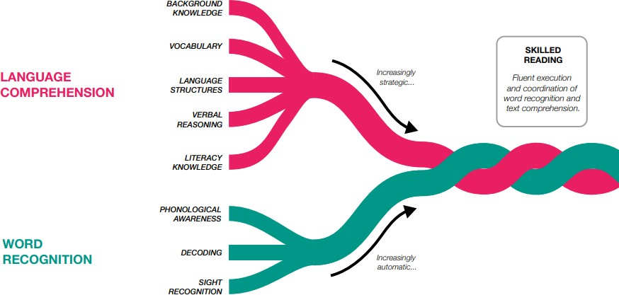
In Key Stage One, the effective and rigorous teaching of synthetic phonics
- Whole class/group phonics is used to explicitly teach phonological awareness.
- Group reading is used to practice reading comprehension and develop fluency
- One to one reading is used to develop fluency and target specific issues children have with reading
- Whole class storytime

Whole class reading | - Teaching the reading toolkit strategies for early decoding: hammer (breaking down sounds), camera (sight words), saw (breaking down longer words), torch (looking for clues in the picture/initial sound), measuring tape (finding a word the right length) and spanner (reading on and finding a word that fits).  - Introduction of the ‘super seven reading strategies’ –predict, question, make links, look for clues, summarise, be a word detective, visualise  - Modelling inference-making and prediction by thinking aloud and scaffolding the thinking of children  - Oral questioning which start to use VIPERS question stems; pupils giving clear oral answers  - Vocabulary discussion and development  - Some texts read repeatedly so children know them inside out (linked to storybook); others chosen to introduce children to the ‘best that has been thought and said’ in early childhood literature
Group reading | - Developing fluency to reduce the cognitive load and allow more emphasis on comprehension through:  - guided oral reading instruction—teachers model fluent reading of a text, then pupils read the same text aloud with appropriate feedback  - repeated reading—pupils reread a short and meaningful passage a set number of times or until they reach a suitable level of fluency  - Discussion of appropriate reading strategies and encouraging children to utilise the strategies for decoding or comprehension.
One to One  reading | Used to develop fluency and confidence, or to focus on specific areas of need using the  Scarborough Reading Rope to identify gaps such as phonological awareness
Interventions
Where children require more support for their reading, areas of need are assessed using the reading rope and fluency. Interventions include:
- 1:1 reading with an emphasis on modelling and practising fluency
- Explicit teaching and practise of phonics with
identified sounds in small groups
Reading for pleasure
- Weekly ‘chatterbook’ chosen from class library
- Regular opportunities for children to discuss their own reading preferences
- Story time for 15 minutes each day
- Whole school initiatives such as ‘Redhill
Reviewers’, or book/poetry day initiatives

 | Phonics | Whole class or guided | Individual | Story time
EYFS/KS1 | 20 minutes daily | 20 minutes weekly | At least once a week | 15 minutes daily

APPENDIX 2: WRITING AT REDHILL
What do we offer? | When do we do it? | Who does it involve? | How?
Regular writing practise with context and opportunities for creativity | Daily | All children and teachers | Every class delivers a daily English lesson focussed on improving writing through focussed grammar objectives, explorations of model texts and the development of a piece of independent writing.
Writing across genres | At least 2-3 genres are explored each term | All children and teachers | Each term, every class looks in depth at a range of genres, exploring high-quality examples, identifying and emulating grammatical features and producing their own piece of extended, independent writing.
A culture of writing for pleasure and celebrating achievements in writing | Class teachers generate a culture of writing for pleasure and celebrating writing in their classrooms. | All children and staff | Writing opportunities are engaging and exciting. Classrooms have stimulating writing displays for children to enjoy and examples of good writing are shared and displayed around school. Extended pieces of writing are regularly given an opportunity to be ‘published’ in some form.
Writing across the curriculum | Regular opportunities for extended pieces of writing in foundation subjects | Teachers | Children are provided with regular opportunities to practise and embed their writing skills by producing extended pieces of writing across the foundation subjects, sometimes in lieu of an extended piece of writing in English.
Spelling | KS1—Daily phonics lessons  KS2—At least two dedicated spelling sessions per week.  Interventions for identified children | Teachers with the support of teaching assistants | We deliver a dedicated and focussed phonics programme throughout key stage 1 followed by a clear, progressive spelling scheme throughout key stage 2.
Handwriting | Dedicated handwriting session once per week  Interventions for identified children | Teachers with the support of teaching assistants | We have high standards of presentation in all of our work and these standards are regularly reinforced through focussed handwriting sessions covering a key, targeted handwriting skill.
Grammar | Focus grammar objectives every week | Teachers | Our grammar teaching is interwoven in to our English sessions and, each week, the children learn the relevant skills and knowledge for their year group and the genre they are studying.

Our Intent
Our aim is to produce children who write with confidence and accuracy for a variety of purposes and audiences whilst developing their own individual flair. We want our children to be able to write with grammatical accuracy and be able to apply spelling patterns correctly using a neat handwriting style. We aim to expose our children to a wide range of vocabulary so that they able to decipher new words and then use them when speaking both informally and formally.
We expect our children to apply all of these English skills to all areas of the curriculum and to utilise their language and literacy skills and knowledge in all subjects and in their everyday lives.
Our approach is underpinned by high expectations; all children are expected to make accelerated progress from their starting points and we expect that every child, where possible, passes the phonics check in Year 1. In Year 6 we aim for a majority of children to achieve the ‘greater depth’ standard. We have achieved these high standards consistently and Redhill is often placed in the top 10% of schools nationally for reading results. These high expectations also apply to our teachers who we can rely on to teach and model the skills needed to succeed in English, providing examples of good practice and having high expectations
Phonics
Early reading and spelling is taught using synthetic phonics, whereby pupils are systematically taught the phonemes (sounds), how to blend the sounds all through the word for reading, and how to segment the sounds in order to write words. They are taught to use their phonic skills and knowledge as their first approach to reading, but are also taught ‘tricky words’ which do not completely follow the phonic rules.
Our progressive approach to teaching phonics is based on the Letters and Sounds programme which follows 6 phases, systematically building on the skills and knowledge of previous learning. We supplement this with the Jolly Phonics actions for learning sounds and Bug Club, an interactive resource that models the skills of segmenting and blending as well as providing interactive phonetical books and games.
All children in Reception and Key stage 1 take part in a daily twenty minute, high quality phonics sessions. These sessions focus on key reading skills such as decoding to read words and segmenting the sounds in a given word to spell. During Phonics lessons we also teach children to read and write ‘tricky words.’ These are words that you cannot easily be sounded out so children are explicitly taught how to read and write them. Our phonics sessions are designed to be fun and interactive and children’s achievement is carefully and frequently tracked to ensure progress is rapid.
Our phonics programme is under review this year and may be altered once the DfE has completed it’s validation process of a range of programmes in late 2021.

A child’s journey through learning to write
By the end of Reception, we intend for all children to be able to write simple sentences that can be read by themselves and others. They will be able to verbally develop their own narratives and speak in full, coherent sentences. All children will be able to write some irregular common words and spell some words in a phonetically plausible way. They can hold pencils appropriately and show good control of small movements.
By the end of Key Stage 1, they will be able to write simple, coherent narratives about personal experiences or those of others. They will be able to write for a range of purposes and make some simple edits and corrections when proofreading their work. They can use co-ordination and some subjunction to join clauses and can use present and past tense mostly accurately. They will be able to demarcate sentences correctly with capital letters, full stops and question marks where necessary and be able to spell most common exception words and add suffixes to a range of words in their writing.
By the end of Key Stage 2, they will be able to write effectively for a range of purposes and audiences, selecting language that shows good awareness of the reader. When writing, they will integrate dialogue in narratives to convey character and advance the action and use a range of devices to build cohesion. They will be able to use verb tenses consistently and accurately and select vocabulary and grammatical structures that reflect what the writing requires. Their writing will use the range of punctuation taught at key stage 2 mostly correctly and they will be able to spell most words from the year 5/6 spelling list. When writing at speed, they will be able to maintain legibility in their joined writing and have the necessary stamina to uphold this standard throughout longer pieces.

A whole school approach
Each term, every class at Redhill uses a different book at an appropriate level as a basis for much of the curriculum, which helps to make meaningful links between subject areas. Immersing children fully in the world of a story helps to foster enthusiasm for reading and writing. All writing in each class links to the class novel and the focus topic for that term to enable the children to apply and extend their knowledge and understanding through their writing.
We are incredibly proud of the writing that our children produce and we endeavour to instil in our school a culture of reading for pleasure as well as for purpose. We want our children to enjoy writing and to actively seek out opportunities to unleash their imaginations and utilise their writing skills in order to create something special.

Writing composition
Writing is a complex and multifaceted skill. Writing is presented to the children as process with several key components which can be utilised. Pupils are taught each of these components and underlying strategies. A strategy is a series of actions that writers use to achieve their goals and may support one or more components of the writing process. Strategies are carefully modelled and practised and, over time, pupils take increasing responsibility for selecting and using strategies.
The five main components that we focus on are: planning, drafting, editing and publishing. In our writing routine, we have broken this process down in to 15 individual steps that are gradually modelled and taught throughout a child’s journey through school. In our planning sequences, we use a variety of these components to support the children to understand the process of building and refining an extended piece of independent writing.
In order to maximise engagement and enjoyment, we carefully consider the audience and purpose of each piece of writing and use this as a focus for how we can effectively improve and enhance our work.

Handwriting
At Redhill, we have very high standards for presentation and we carefully support the children’s handwriting skills throughout their time at our school. Children are carefully taught the shape of each letter and how to form each letter correctly. They are then encouraged to think about the positioning of their writing based on the space between letters and words, where the letters sit on the line and the consistent size of letters in their work. Once they are confident with these skills, we begin joining and stringing our letters and utilising a slant in the writing to enable fluent joining. When they are competent at this, they can begin focussing on writing at speed and beginning to develop their own style.

Spelling
To develop and sustain children’s ability to spell, they need direct systematic instruction. Spelling, as a key transcription skill, must be explicitly taught, rather than simply tested. Therefore, we have a structured, progressive spelling programme in school and teachers encourage the children to use a range of strategies and techniques, which are examined carefully in class, to assist them in memorising spellings and attempting to spell new words that they encounter.
Children are set targeted, focussed spellings each week to practise at home in order to further develop this skill. Furthermore, we have subscribed to some useful online resources to support learning at home and in school. From reception to Year 2, every child has a subscription to Phonics Bug which they can log on to and practise the sounds that they are learning or revise the sounds they have learnt already. In Key Stage 2, every child has a login for Spelling Shed where they can practise their spelling lists in fun and engaging ways.

APPENDIX 3: Reading at Redhill

What do we offer? | When do we do it? | Who does it involve? | How?
Children read in whole class reading sessions. | KS1 - Once a week  KS2—Daily | All children read with the class teacher and their peers. | A combination of reading strategies are taught and developed such as fluency, comprehension, prosody and deeper reading.
Children are provided with ‘levelled’ texts to take home.  Early readers working through the school phonics programme will take home fully decodable books.  Parents read these books with their children at home. | Rec/KS1– Books go home, and are returned to school, on a Monday.  KS2 – Books can be changed when necessary with support from the class teacher | Checked by class teacher and sometimes supported by teaching assistant. | Staff hand each child a new book from the stage books.  Class teachers decide when children are ready to move up a book band based on word reading, class work and comprehension of a passage.
1:1 reading with children. | Reception: Once per week  KS1: Once per week  KS2: At least once per month | Class teacher and teaching assistants where necessary. | Teachers read with children checking word reading and comprehension skills.
Children are provided with opportunities to read for pleasure. | Class teachers generate a culture of reading for pleasure within their classrooms. | All children and staff. | Classrooms have stimulating reading displays for children to enjoy.  Teachers plan regular opportunities for children to read for pleasure within the timetable.
Children have access to a wide range of books from a selection taken from the library. | Children can borrow books to read at home or for pleasure in school. | All children. | Staff take a selection of books into the classroom for children to choose from.
Texts linked to the topic are shared and studied through English lessons. | Daily | All children and all teachers. | A quality text is the focus of all of our topics. Classes will identify features, discuss themes, explore new vocabulary and learn and analyse the structure through our English lessons.
Teachers model positive reading behaviours by reading to the class. | Daily | All children and teachers. | A quality text aimed at being above the children’s reading age is read to the children to foster a love of reading, model core reading skills (particularly fluency) and extend pupil vocabulary.
Our Intent
At Redhill we are very proud of our rigorous and successful approach to the teaching of reading. Our aim is excellence: we expect that every child, where possible, passes the phonics check in Year 1. In Year 6 we aim for a majority of children to achieve the ‘greater depth’ standard. We have achieved these high standards consistently and Redhill is often placed in the top 10% of schools nationally for reading results.
Success in reading has a direct effect upon progress in all other areas of the curriculum. It is crucial in developing children’s self-confidence and motivation. At Redhill we want every child to become confident, enthusiastic and self-reflective readers. For the teaching of early reading to be successful, it needs a balanced and creative approach in a context of rich oral language development. This should include the systematic teaching of phonics, as well as focus on application, exploring comprehension and meaning, and reading enjoyment. Oracy is key to developing reading and writing skills and a focus on drama at Redhill provides a vehicle for developing speaking skills throughout school.
We want children to read for pleasure: motivation to read is a crucial component of a teacher's job and teachers at Redhill seek to nurture a love of reading in children. Teachers are enthusiastic about books and reading, inspiring children to read. This is vital in helping us to achieve our high standards. We believe it is important to immerse children in a rich reading environment which we achieve through our ‘storybook curriculum’ which places books at the heart of what we teach.

Phonics
Early reading is taught using synthetic phonics, whereby pupils are systematically taught the phonemes (sounds), how to blend the sounds all through the word for reading, and how to segment the sounds in order to write words. They are taught to use their phonic skills and knowledge as their first approach to reading, but are also taught ‘tricky words’ and common exception words which do not completely follow the phonic rules.
Our progressive approach to teaching phonics follows the DfE approved Phonics Bug programme which all classes follow for the teaching of phonics and early reading. In this scheme, we systematically build on the skills and knowledge of previous learning. We also use the online Bug Club resource - an interactive resource that models the skills of segmenting and blending as well as providing interactive phonetical books and games.
All children in Reception and Key stage 1 take part in a daily twenty minute, high quality phonics sessions. These sessions focus on key reading skills such as decoding to read words and segmenting the sounds in a given word to spell. During Phonics lessons we also teach children to read and write ‘tricky words’ and common exception words. These are words that cannot easily be sounded out so children are explicitly taught how to read and write them. Our phonics sessions are designed to be fun and interactive and children’s achievement is carefully and frequently tracked to ensure progress is rapid.
A typical child’s journey when learning to read
Children learn how to associate letter sounds (phonemes) with their corresponding letter pattern (grapheme).
Children learn how to blend clusters of these letter patterns to form words. This is known as decoding. At the same time, their knowledge of the most commonly seen words (high frequency words) increases.
Children begin to broaden their awareness of words which do not conform to general grapheme ‘rules’ (tricky words).
Children learn alternative letter patterns for known sounds (such as ‘or’ being also less commonly being represented as ‘aw’, ‘ore’, ‘our’ and also ‘au’ as in August).
Throughout this process, children read age-appropriate books with lots of opportunities to apply the sounds they have learnt. They are taught to answer questions related to the text and encouraged to query the action or content of the text whilst reading; they do this orally and in writing. This continues to develop with age and experience and children learn to establish a greater understanding of the printed word by being able to explain new vocabulary, retrieve information, make inferences and discern the choice of language and authorial intent.

A whole school approach
Each term, every class at Redhill uses a different book at an appropriate level as a basis for much of the curriculum, which helps to make meaningful links between subject areas. Immersing children fully in the world of a story helps to foster enthusiasm for reading. It also means that, by the end of Key Stage 2, every child will have read a variety of high quality and challenging novels. Each teacher reads aloud to their class on a daily basis and constantly look for ways to inspire readers. As a result children are able to talk confidently about genres and authors they enjoy.

Reading fluency and comprehension
Reading is a multi-faceted skill. Our phonics approach enables children to make the best start with decoding and phonological awareness, leading to word recognition. The teaching of reading throughout school is designed to build on this, providing opportunities for children to learn and practise comprehension and fluency skills, using the National Curriculum as our framework. We have a clear progression which sets out, for each year group, what provision is made for 1:1 reading, group reading and the whole class teaching of reading skills. We VIPERS for the explicit teaching of comprehension skills, with the aim of helping children become active, reflective readers. The VIPERS skills are: understanding and explaining new Vocabulary; making Inferences and asking questions; making Predictions; Explaining our answers and authorial choices using evidence from the text; Retrieving information; and Summarising the events from a text. To support these skills, we send home a year group specific bookmark each half term with a reading target and some possible question stems that you could use whilst reading at home.

What should your child read at home?
The reading your child completes during the week can be taken from a wide range of sources, such as the school book your child brings home; a text your child has at home (or from the library, for example); and other reading material, e.g. comics. Any additional reading children want to do from a familiar or favourite text or author is encouraged.
Please remember that the purpose of the ‘Levelled’ books is to consolidate earlier reading skills, increase fluency, ensure children can decode age-appropriate vocabulary, build confidence and have a good understanding of what has been read. To avoid gaps in learning, the aim is not to progress through the scheme stages/levels as quickly as possible. The class teacher will regularly listen to your child read in school and decide when they are ready to move to the next book band and have the appropriate level of reading skill and fluency to access these books at home.
Online resources
To further support learning from home, we have subscribed to some useful online resources. From reception to Year 2, every child has a subscription to Phonics Bug which they can log on to and practise the sounds that they are learning or revise the sounds they have learnt already.
In Key Stage 1, every child has a login for Reading Eggs which is a fun resource for developing reading and comprehension skills. In Key Stage 2, Reading Eggs changes to Reading Eggspress. All children in Key stage 2 will have a login for this site and can use it to develop their reading and comprehensions skills too.

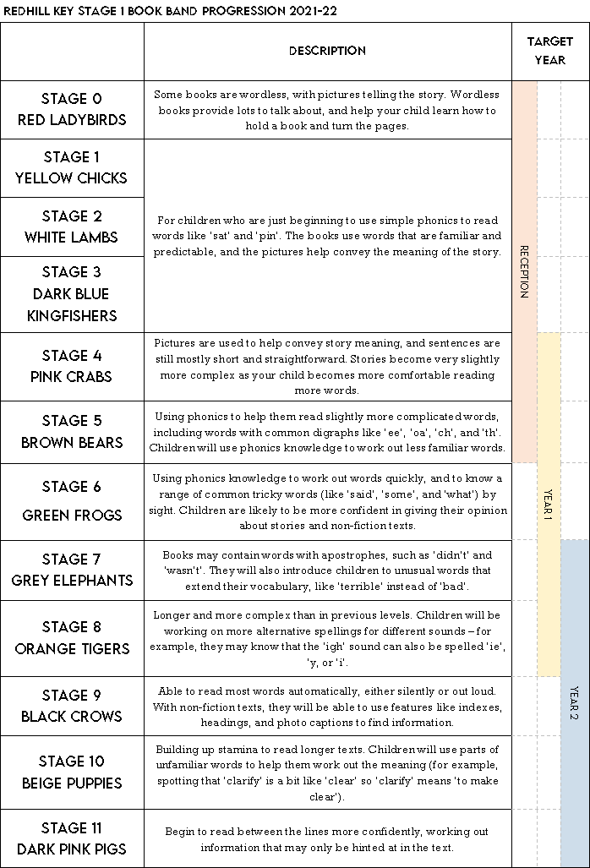

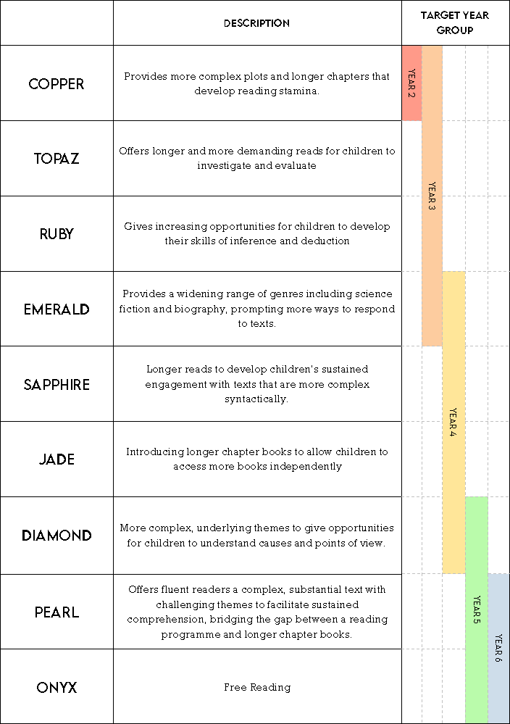

APPENDIX 4: Phonics at Redhill
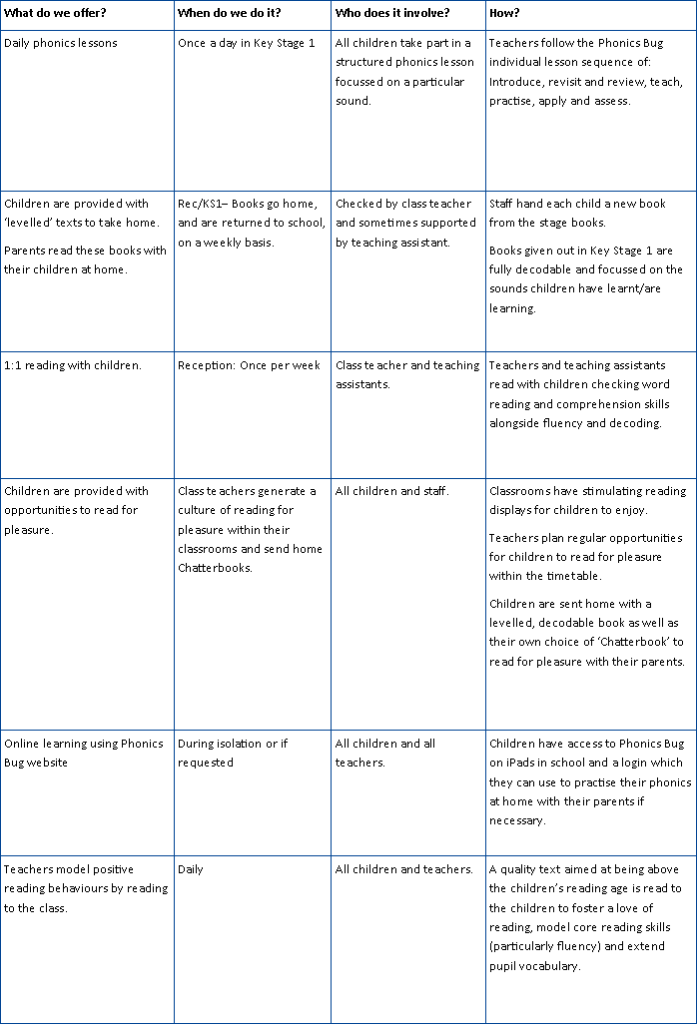
Our Intent
At Redhill we are very proud of our rigorous and successful approach to the teaching of reading. Our aim is excellence: we expect that every child, where possible, passes the phonics check in Year 1. In Year 6 we aim for a majority of children to achieve the ‘greater depth’ standard. We have achieved these high standards consistently and Redhill is often placed in the top 10% of schools nationally for reading results.
Success in reading has a direct effect upon progress in all other areas of the curriculum. It is crucial in developing children’s self-confidence and motivation. At Redhill we want every child to become confident, enthusiastic and self-reflective readers. For the teaching of early reading to be successful, it needs a balanced and creative approach in a context of rich oral language development. This should include the systematic, synthetic teaching of phonics, as well as focus on application, exploring comprehension and meaning, and reading enjoyment. Oracy is key to developing reading and writing skills and a focus on drama at Redhill provides a vehicle for developing speaking skills throughout school.
We want children to read for pleasure: motivation to read is a crucial component of a teacher's job and teachers at Redhill seek to nurture a love of reading in children. Teachers are enthusiastic about books and reading, inspiring children to read. This is vital in helping us to achieve our high standards. We believe it is important to immerse children in a rich reading environment which we achieve through our ‘storybook curriculum’ which places books at the heart of what we teach.

Phonics
Early reading is taught using synthetic phonics, whereby pupils are systematically taught the phonemes (sounds), how to blend the sounds all through the word for reading, and how to segment the sounds in order to write words. They are taught to use their phonic skills and knowledge as their first approach to reading, but are also taught ‘tricky words’ and common exception words which do not completely follow the phonic rules.
Our progressive approach to teaching phonics follows an the DfE approved Phonics Bug programme which all classes follow for the teaching of phonics and early reading. In this scheme, we systematically build on the skills and knowledge of previous learning. We also use the online Bug Club resource - an interactive resource that models the skills of segmenting and blending as well as providing interactive phonetical books and games.
All children in Reception and Key stage 1 take part in a daily twenty minute, high quality phonics sessions. These sessions focus on key reading skills such as decoding to read words and segmenting the sounds in a given word to spell. During Phonics lessons we also teach children to read and write ‘tricky words’ and common exception words. These are words that cannot easily be sounded out so children are explicitly taught how to read and write them. Our phonics sessions are designed to be fun and interactive and children’s achievement is carefully and frequently tracked to ensure progress is rapid.

A typical child’s journey when learning to read
Children learn how to associate letter sounds (phonemes) with their corresponding letter pattern (grapheme).
Children learn how to blend clusters of these letter patterns to form words. This is known as decoding. At the same time, their knowledge of the most commonly seen words (high frequency words) increases.
Children begin to broaden their awareness of words which do not conform to general grapheme ‘rules’ (tricky words and common exception words).
Children learn alternative letter patterns for known sounds (such as ‘or’ being also less commonly being represented as ‘aw’, ‘ore’, ‘our’ and also ‘au’ as in August).
Throughout this process, children read age-appropriate books with lots of opportunities to apply the sounds they have learnt. They are taught to answer questions related to the text and encouraged to query the action or content of the text whilst reading; they do this orally and in writing. This continues to develop with age and experience and children learn to establish a greater understanding of the printed word by being able to explain new vocabulary, retrieve information, make inferences and discern the choice of language and authorial intent.

What is systematic synthetic phonics?
In systematic synthetic phonics the graphemes and corresponding phonemes are taught just before the introduction of words that contain these letters. To read these words, children are taught to pronounce the individual phonemes (sounds) associated with the graphemes (letters) they see, and then to blend them together (synthesise) to form the word. The process is as follows:
• Children see a word, e.g. cat; it is not pronounced for them.
• They break it down into its individual letters (graphemes) and pronounce the corresponding sounds (phonemes) for each letter in turn: /c/ /a/ /t/
• Then they blend the separate phonemes together to form the word.
This process is known as blending.
Systematic synthetic phonics teaches letter sounds very rapidly, explicitly showing children how to build up words with letters from the start, and always includes blending with printed words.
Systematic synthetic phonics does not normally teach spelling, but Bug Club Phonics does teach spelling by reversing the reading process described above, i.e.
• Children hear a word, e.g. ‘cat’ and say it.
• They say the first phoneme: /c/.
• They write the corresponding grapheme: ‘c’.
• They say the word again and say the next phoneme: /a/.
• They write the corresponding grapheme: ‘a’, and so on.
This process is known as segmenting, and is followed by the children reading the word they have produced by sounding and blending.
In our approach, both blending for reading and segmenting for spelling are fully scaffolded. We model for the children how to sound and blend words for reading, but in each lesson children must attempt to sound and blend words for themselves to find out how they are pronounced. We also model for the children how to segment for spelling and continue to scaffold the children through the process with each word they spell. This ensures that they identify each phoneme and choose the appropriate grapheme in turn, until the word is spelt.
Why do we use systematic synthetic phonics?
The Reading Framework, published by the Department for Education in July 2021, states that:
‘Evidence shows that teaching phonics is the best way to teach children to read, e.g. the EEF considers phonics to be one of the most secure and best-evidenced areas of pedagogy, recommending all schools use a systematic approach to teaching it. There is convincing evidence of the value of systematic synthetic phonics (SSP), including the seven-year study by Johnston and Watson undertaken in Clackmannanshire, published in 2005, which has been especially influential in England.’
The aforementioned study involved dividing around 300 Primary aged children into three groups. One group was taught via the synthetic phonics method, one by a standard analytic phonics programme, and the third by an analytics phonics programme which included systematic phonemic awareness teaching without reference to print.
The outcomes of the study proved overwhelmingly that the synthetic phonics approach is more effective than the analytic phonics approach. Evidence shows that synthetic phonics is best taught at the beginning of Key Stage 1, as even by the end of Year 2 the children had better ability. At the end of the programme, the synthetic phonics-taught group were reading and spelling seven months ahead of their expected level. It has also proven to help close the gender gap with boys’ word reading accelerating, and sometimes measuring ahead of girls.
Teachers and head teachers have responded positively to synthetic phonics teaching, having found that their pupils' reading and spelling skills are much improved and that those underachieving can be identified earlier.

Structure of Phonics lessons

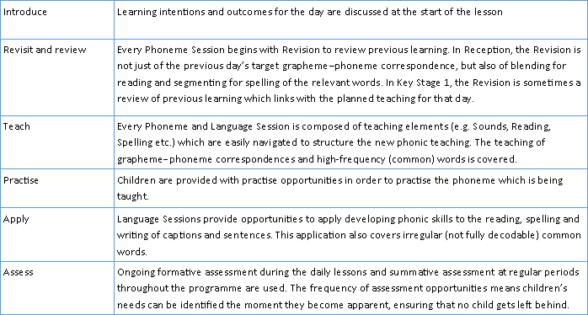

Bug Club Phonics online
Bug Club Phonics provides frequent opportunities for children to practise reading the GPCs they have been taught in words and texts remotely.
In Phoneme Sessions:
• children are given opportunities to practise reading words composed of previously taught grapheme–phoneme correspondences
• the process of sounding and blending the new grapheme– phoneme correspondence in words is modelled and children are also expected to attempt to sound and blend words containing it for themselves
Language Sessions consolidate the teaching of reading in Phoneme Sessions by providing opportunities to apply developing phonic skills to the reading of words, captions and sentences.
To consolidate teaching from the Phoneme and Language Sessions, children can remotely access allocated digital games (for both practice and assessment) which provide reading practice of the previously taught phonics.
What should your child read at home?
The purpose of the ‘Levelled’ books is to consolidate earlier reading skills, increase fluency, ensure children can decode age-appropriate vocabulary, build confidence and have a good understanding of what has been read. To avoid gaps in learning, the aim is not to progress through the scheme stages/levels as quickly as possible. The class teacher will regularly listen to your child read in school and decide when they are ready to move to the next book band and have the appropriate level of reading skill and fluency to access these books at home.

